**Enquiry topic—Churchill 1930-1951**

* Why was Winston Churchill out of office for so long?
* Why did he become Prime Minister in 1940?
* What were Churchill’s views on international diplomacy?

**Period Study—Britain 1951-1997**

* Why were the Conservatives able to dominate politics from 1951 to 1964?
* Labour and Conservative governments 1964-1979.
* Why was there an end of ‘consensus politics’ under Margaret Thatcher?
* Britain’s position in the world, 1951-1997.

**Task 1: Getting to know Winston Churchill**

You will carry out a compulsory source question on Winston Churchill in Unit 1 so it would be advisable to read a biography of Winston Churchill. There are many out there, but a great way to start is to make use of the BBC Teach resource: <https://www.bbc.co.uk/teach/sir-winston-churchill-the-greatest-briton/zr3747h>

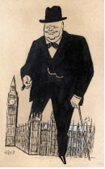

Using this website, **create a 2-page fact file or poster of Churchill.** Think about the earlier years of Churchill’s life, before he became Prime Minister, and include information we might not know; where did he go to school for example, who were his parents, who did he marry, what jobs did he do? He may have been voted the ‘greatest Briton’ in 2002, but he is a complex character with some questionable views!

There are some great films about Churchill: Gary Oldman’s Oscar-winning performance in “The Darkest Hour” is a positive portrayal whilst Brian Cox’s interpretation in “Churchill” gives a more critical view. Watch at least one film and **write a 200-word summary** of what you felt about the film in terms of historical interpretation. Is it historically accurate, does it exaggerate for dramatic effect, how effective was it in helping you learn about Churchill? What was the best part of the film and why?

**Challenge: Getting to know those around Churchill**

We will spend a lot of time looking at historical sources about Churchill and it is vital that we, as historians, know the origin and context of the source. You can either create mini-fact files or create a visual organogram/mindmap of who’s who and how they are connected.

Research the following people: Edward VIII / Wallis Simpson / Lord Beaverbrook / Duff Cooper / Stanley Baldwin / Neville Chamberlain / Anthony Eden / Sir Roger Keyes / Lord Halifax / Leo Amery / Clement Atlee / Sir John Colville / General Ismay / Air Alan Brooke / Lord Cherwell / Aneurin Bevan. For each one, note down who they are, their date of birth/death, what was their most important role in the 1930s/1940s, and how are they connected to Churchill (and each other) - are they friends or enemies?

**Task 2: What was Britain like in the 1930s?**

Britain in the 1930s was very different to the Britain of today – or was it? The Wall Street Crash of October 1929 had triggered a global economic depression and Britain had not fully recovered from WWI. The Conservative Party was in power but as part of a ‘National Government’.

Research the 1930s. You can do this in several ways. Reading and making notes is the most obvious way to learn, but you can get a feel for the period by reading novels, watching documentaries and historical dramas. You might be able to visit historical sites, if not then explore museum websites.

**Task**: Create a timeline of key events of the 1930s. Choose 10 events that interest you. The following websites are helpful: <http://www.bbc.co.uk/history/british/timeline/worldwars_timeline_noflash.shtml/> <https://www.bl.uk/learning/timeline/item124207.html>

**Now choose 2 of the options below**:

1. Read a novel set in the pre-war period. You can choose from a wide range. Here are some suggestions:

* Aldous Huxley's *‘A Brave New World’*
* George Orwell *‘The Road to Wigan Pier’*
* Virginia Woolf *‘Mrs Dalloway’*
* E.M. Forster *‘A Passage to India’*
* Evelyn Waugh *‘Vile Bodies’*
* Agatha Christie novels.

**Write a 200-word summary** of what you have learnt from this novel about Britain in the pre-war period.

1. Choose one of the events from the National Archives 1930s page: <https://www.nationalarchives.gov.uk/education/resources/thirties-britain/> and create an **A3 poster** detailing what you have learnt.
2. Create a **10-question quiz** from the information on the ‘Gateway to Britain, 1929’ page (see below).

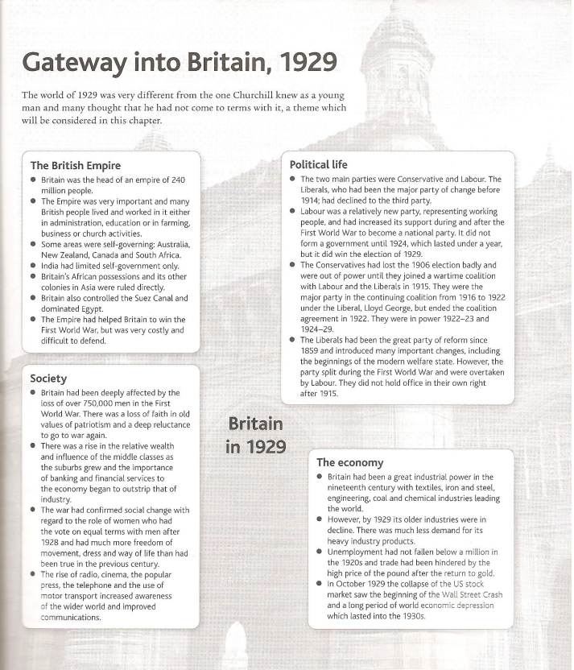

**Reading list/films/documentaries for Unit Y113: Britain 1930-1997**

**Set textbook:** 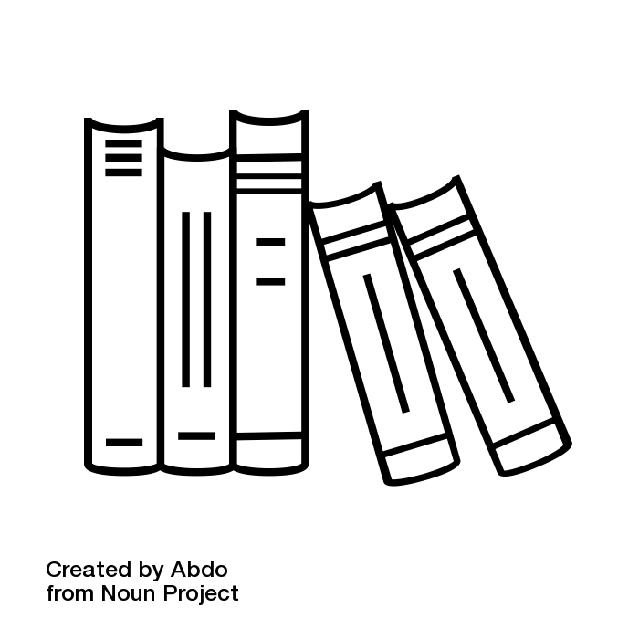

OCR Britain 1930-1997, Mike Wells and Nicholas Fellows (this can be purchased at school in September)

**Advisable to also purchase:**

Access to History: Britain 1900-57 Second Edition UK ed. Edition, Michael Lynch Peter Clarke - Hope and Glory: Britain 1900-2000: Updated to Cover 1992-2002 (Penguin History of Britain)

**Useful websites:** <https://www.nationaltrust.org.uk/chartwell/lists/curators-choice-five-must-sees-at-chartwell> <https://www.iwm.org.uk/visits/churchill-war-rooms> <https://www.nationalarchives.gov.uk/cabinetpapers/maps-in-time.htm>

**Biographies of Winston Churchill:**

There are many, and a lot of them a very detailed. But either Roy Jenkins’ ‘Churchill’ or Geoffrey Best’s ‘A Study in Greatness’ are excellent.

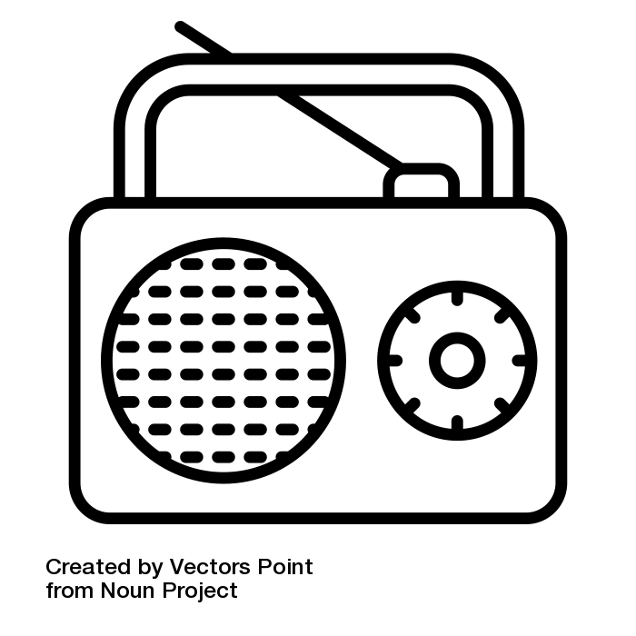

**Documentaries/podcasts:**

* Search: BBC Radio 4 Winston Churchill: <https://www.bbc.co.uk/programmes/p02gx4g5>
* History Extra – lots of podcasts on lots of topics very useful for Historians: <https://www.historyextra.com/article-type/podcast/>
* The Rest is History Podcast: <https://podcasts.apple.com/gb/podcast/britain-in-1974-state-of-emergency-part-1/id1537788786?i=1000643911801>
* Great Lives: <https://www.bbc.co.uk/programmes/b00tpsvk>
* Thatcher: A Very British Revolution: <https://www.bbc.co.uk/iplayer/episode/m0005br9/thatcher-a-very-british-revolution-series-1-1-making-margaret> 

And if you can watch The Crown on <https://www.netflix.com/browse>, this pretty much covers our course (although not always historically correct!)